**V0.5**

This is the first version which simply has buttons with no input box, present in BenchBotDocs/GUI/Prod Files/v0.5 directory.

‘START’: Click on this button to power on the Machine Motion.

‘Forward’: Click on this button to move the BenchBot in forward direction with pre-set distance of 50 mm and speed of 50 mm/rev.

‘Backward’: Click on this button to move the BenchBot in reverse direction with pre-set distance of 50 mm and speed of 50 mm/rev.

’STOP’: Click on this button to power off the Machine Motion.

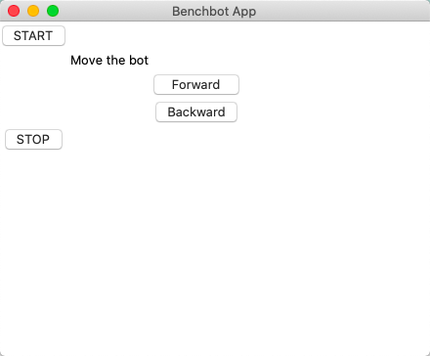

**V1.0**

This version has 1 input box with 4 buttons, present in BenchBotDocs/GUI/Prod Files/v1.0/ArgsGUI directory.

‘START’: Click on this button to power on the Machine Motion.

‘Distance’: Put in the distance in mm by which the BenchBot needs to be moved.

‘Forward’: Click on this button to move the BenchBot in forward direction by distance entered by the user, with pre-set speed of 50 mm/rev.

‘Backward’: Click on this button to move the BenchBot in reverse direction by distance entered by the user, with pre-set speed of 50 mm/rev.

’STOP’: Click on this button to power off the Machine Motion.

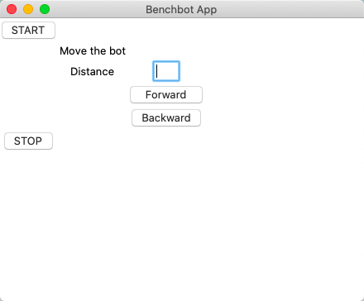

**V1.5**

This slightly updated version has 2 input boxes with 4 buttons, present in BenchBotDocs/GUI/Prod Files/v1.0/2ArgsGUI directory.

‘Forward’: Click on this button to move the BenchBot in forward direction by distance entered by the user with user defined speed.

‘Backward’: Click on this button to move the BenchBot in reverse direction by distance entered by the user with user defined speed.

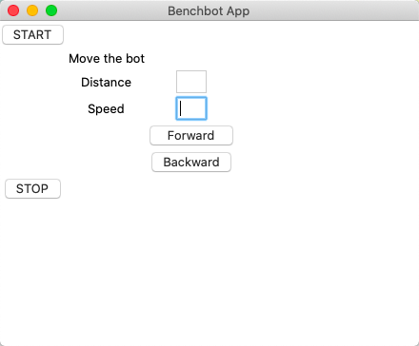

**V2.0**

This version has 2 input fields with 5 buttons, file BenchBotDocs/GUI/Prod Files/v2.0/GUI1.py.

‘Distance’: Put in the distance in cm by which the BenchBot needs to be moved.

‘Speed’: Put speed in terms of cm/rev for moving the BenchBot. Speed can also be entered using the spinbox, both are linked.

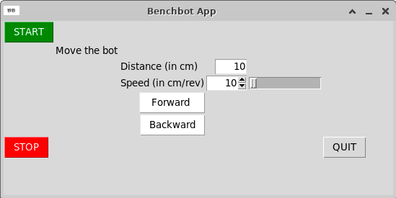

*This version includes validation for the fields, the fields only take numeric inputs and have a default value so blank fields are also accepted.

**V2.5**

File is BenchBotDocs/GUI/Prod Files/v2.0/GUI2.py. As compared to v2.0, this version has an additional button to launch a new window to allow control of BenchBot in all directions.

In ‘Free Control’ window, click and hold mouse left button to register the location values of the cursor according to which the bot moves. It is set as a Cartesian plane in which x value decides orientation (turn ratio) and y value decides the speed of the bot motion.

